
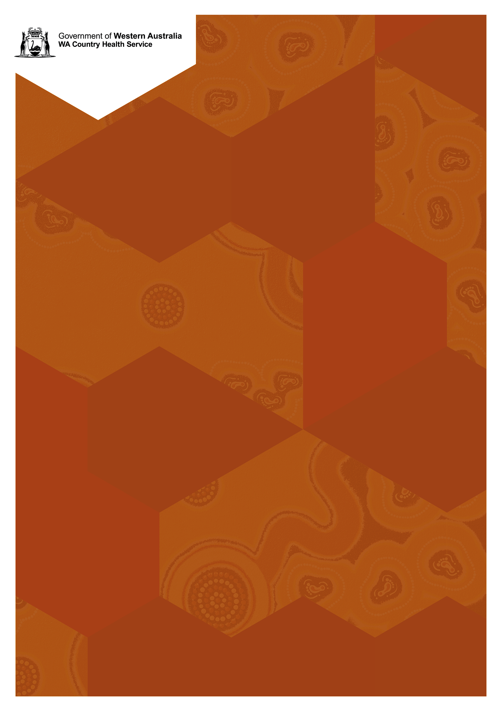
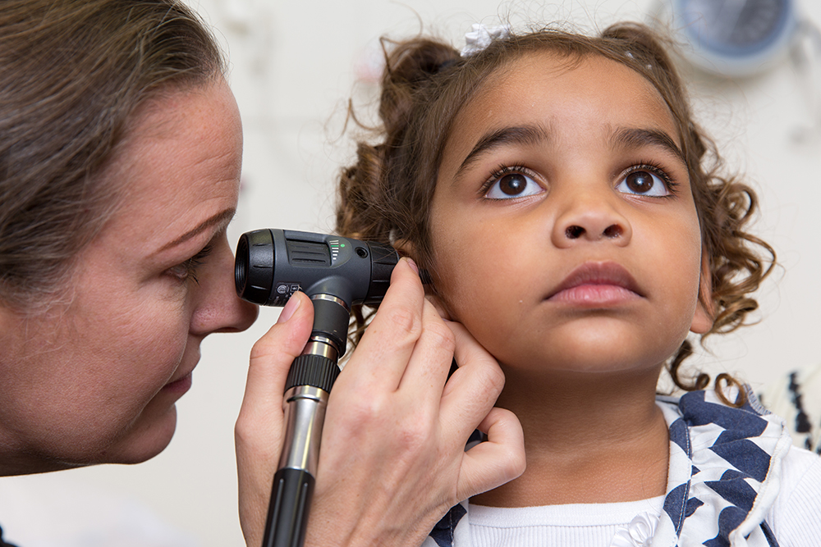


Social Media Training
Facilitated by Hancock Creative
For all staff from health, education or community organisations that use social media or are looking into using social media.

Date: Tuesday 22 October 2019
Full day
Venue: Block 18 Kalgoorlie Health Campus
*VC can be arranged*
RSVP: Monday 7th October for catering purposes

Supported by Sexual Health and Blood-borne Virus Program
This is a catered event
Register early as places are limited.
More information
Get in touch
Nerissa Battye

90808200
or
nerissa.lewin@health.wa.gov.au
The painting used for graphic illustration in this document is the work of artist Aaron Hayden. To provide feedback on this publication email wachscomms@health.wa.gov.au. © WA Country Health Service
The painting used for graphic illustration in this document is the work of artist Aaron Hayden. To provide feedback on this publication email wachscomms@health.wa.gov.au. Alternative formats can be provided on request. © WA Country Health Service

